
Workbook + Expert Analysis

What is your ‘One Word’?

For Any Questions: Email My Team at TheRichKeller.com/CONTACT

© 2024 Transformational Alchemist, LLC. All rights reserved.
This workbook, including its content, design, and layout, is protected by copyright law and may not be reproduced, distributed, or transmitted in any form or by any means, electronic or mechanical, including photocopying, recording, or by any information storage and retrieval system, without prior written permission from the copyright owner. Unauthorized reproduction, distribution, or sharing of this workbook is prohibited. To request permission for use, please contact: info@therichkeller.com
Table of Contents
(click the section below to jump back in)

Welcome Note
Directions
Questionnaire
Part 1: What makes you YOU?
Part 2: What are your strengths/challenges?
Part 3: How do others view you?
Part 4: Input from others
Next Steps

WELCOME
I’m Rich Keller and my mission is simple: To transform 1 million lives ‘One Word’ at a time. I'm honored that you have selected me to serve as your mentor while you create your 'One Word’ personal brand.
I spent more than 25 years crafting identities for some of the world’s most iconic brands (e.g. Godiva chocolates, Chips Ahoy! cookies, and Planters peanuts, to name a few). I did this by uncovering the quality that consumers value most - and labeled this core value with ‘One Word’.
My quest to reinvent myself started in 2014 when I lost my position as Vice President of Marketing. A recruiter I spoke with during my next job hunt made a statement that would forever alter my life. Instead of making me a job offer, she informed me that I wasn't the best fit for the position. I distinctly recall saying, "Are you kidding me? I meet every qualification," as I turned to face her. "Yes you do, except for one thing," she responded. She said, "You're a CATALYST and they're looking for a babysitter.”
That's when I experienced my "a-ha" moment and my mind suddenly lit up. An agent that accelerates or causes major change without affecting itself is called a CATALYST. I defy convention in order to provoke thought and advance progress. That recruiter helped me understand my identity and my 'One Word’ personal brand was born.
Fast forward almost 10 years later and I’m now the CATALYST who supports people just like you in finding your ‘One Word’ so they can embrace who they are, just like I did.
Welcome to my personal branding philosophy: The Power of ‘One Word’!
Now it’s your turn to simplify your personal brand down to ‘One Word’…
Stand-out with ‘One Word’:
You will discover your own core value and label it with ‘One Word’.
Conquer Obstacles with ‘One Word’:
You will gain the clarity needed to boldly and decisively tell your story and cut through the noise.
Reach Excellence with ‘One Word’:
You will succeed as an entrepreneur, move up the corporate ladder, land your dream job, or gain a college acceptance because you will now be able to align what you do with who you are.
Are you ready to discover your ‘One Word’?
All it takes is ‘One Word’ to Stand-out Conquer Obstacles Reach Excellence…in other words, SCORE!
DIRECTIONS
This Workbook is a tool that will help you begin the journey of discovering your core value, which I define as who you are and the impact you make…NOT what you do. You will learn how to express this core value with ‘One Word’. To help you step into who you are, you will answer questions that will help you identify what makes you you, your strengths/challenges, how others view you, and the impact that you hope to make on the world.

As you proceed through this Workbook, be honest and open-minded. The more thought and effort you put into this process, the more you will get out of it. There are no wrong answers. Write the first thing that comes to mind, then let it sit for a while and re-read it later to see if you can build on your answers.

Explore the answer to each question from a variety of perspectives, including personal, professional and your activities/interests. Some of the questions will encourage you to view yourself through the eyes of friends, colleagues and/or family members.

Once you’ve completed the eleven questions, simply upload your workbook following the instructions at the end, and I’ll take it from there. You provide me with the ingredients, and I’ll help you create a beautiful cake—your ‘One Word’ core value.

Remember, what you do is NOT who you are…but who you are should drive what you do!

All it takes is ‘One Word’ to Stand-out Conquer Obstacles Reach Excellence!

Get ready to SCORE!

PS: I encourage you to watch my TEDx talk before you begin. Click here.

QUESTIONNAIRE
PART 1: WHAT MAKES YOU YOU?
1) What is your current job/profession/stage of education?
Note: If you’re not employed, what is the activity that most occupies your time?
Type your answer here.
- What is the next stage of your job/profession/stage of education?
Type your answer here.

- Why does that excite you?

Type your answer here.

2) As a child:
- What did you want to be when you grew up?
Type your answer here.

- Why?
Type your answer here.

3) Please share 10 situations, activities, hobbies, or anything else that make you feel alive and explain why.
Note: Think about what gets you out of bed in the morning. It can be something that you’re currently doing or would like to pursue in the future.

#1 Type your answer here.
#2 Type your answer here.
#3 Type your answer here.
#4 Type your answer here.
#5 Type your answer here.
#6 Type your answer here.
#7 Type your answer here.
#8 Type your answer here.
#9 Type your answer here.
#10 Type your answer here.

PART 2: WHAT ARE YOUR STRENGTHS/CHALLENGES?
4) Please share 10 things you excel at and why you’re great at them.
Note: Think about this question through the lens of your professional life, your personal life, or what you would want to convey to someone asking you about yourself.

#1 Type your answer here.
#2 Type your answer here.
#3 Type your answer here.
#4 Type your answer here.
#5 Type your answer here.
#6 Type your answer here.
#7 Type your answer here.
#8 Type your answer here.
#9 Type your answer here.
#10 Type your answer here.
5) Select 5 accomplishments you are most proud of in your personal and/or professional life. When answering, please include:
- Specifically, what was the accomplishment and your role?
#1 Type your answer here.
#2 Type your answer here.
#3 Type your answer here.
#4 Type your answer here.
#5 Type your answer here.

b. What did you learn about yourself from each experience?
#1 Type your answer here.
#2 Type your answer here.
#3 Type your answer here.
#4 Type your answer here.
#5 Type your answer here.
6) What has been your biggest challenge to date and how have you addressed or overcome it?
Type your answer here.
7) What is your biggest weakness or aspect of yourself that you would most like to improve upon?
Type your answer here.
PART 3: HOW DO OTHERS VIEW YOU?
8) From your own perspective, how do you think others would describe you? Feel free to list as many one-word descriptors as you’d like for each category.
- Family
Type your answer here.
- Friends
Type your answer here.
- Classmates/Co-Workers/Peers
Type your answer here.
9) What personal and professional advice do people turn to you for?
Note: Think about this question through the lens of everyday challenges and situations from different stages of your life (e.g., high school, college, career, hobbies and interests).

Type your answer here.
10) When you pass on, what do you hope to be remembered for (Your legacy)?
Type your answer here.

PART 4: INPUT FROM OTHERS
11) Select 5 people who play different roles in your life—choose at least one friend, one co-worker/colleague/classmate, and one family member—and ask each of them to answer this question: “What makes you unique?” Feel free to give them the freedom to write as much as they'd like.
Note: Please select people who know you well enough to offer a constructive perspective.

Type your answer here.

Next Steps To Upload And Send
Your Workbook To Rich Keller…

Step 1: Click file on the top left of the screen in Google Docs -
then click download - then choose to save as Microsoft Word (.docx)
or PDF Document (.pdf)

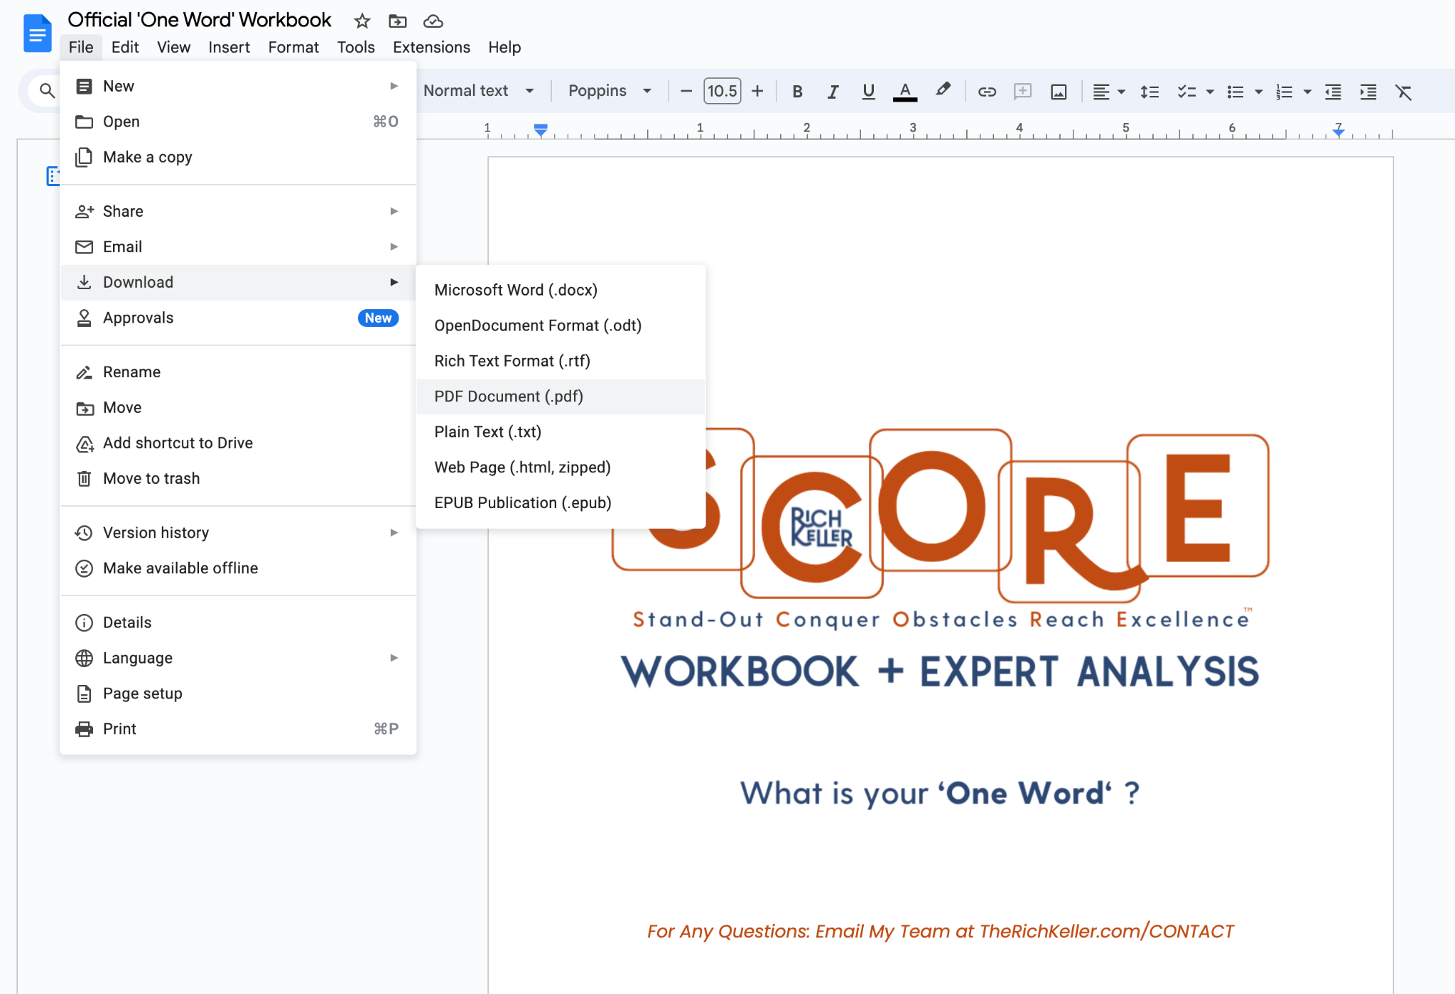

Step 2: go to www.therichkeller.com/submit
Fill out the form and upload your workbook as a pdf or word doc.

Once you hit send, you’ll receive a notification that your workbook has been received. Rich will then reach back out to you to schedule an analysis zoom call after he reads your workbook.

